CSA1509-Cloud computing and big data analytics
Experiment-2
Create a simple cloud software application for Real Estate Buying & Rental process (In
Bengaluru city) using any Cloud Service Provider to demonstrate SaaS include the
necessary fields such as Buy, Rent, commercial, Rental Agreement , Rental
Agreement, Area, place, Range, property value etc.
Input
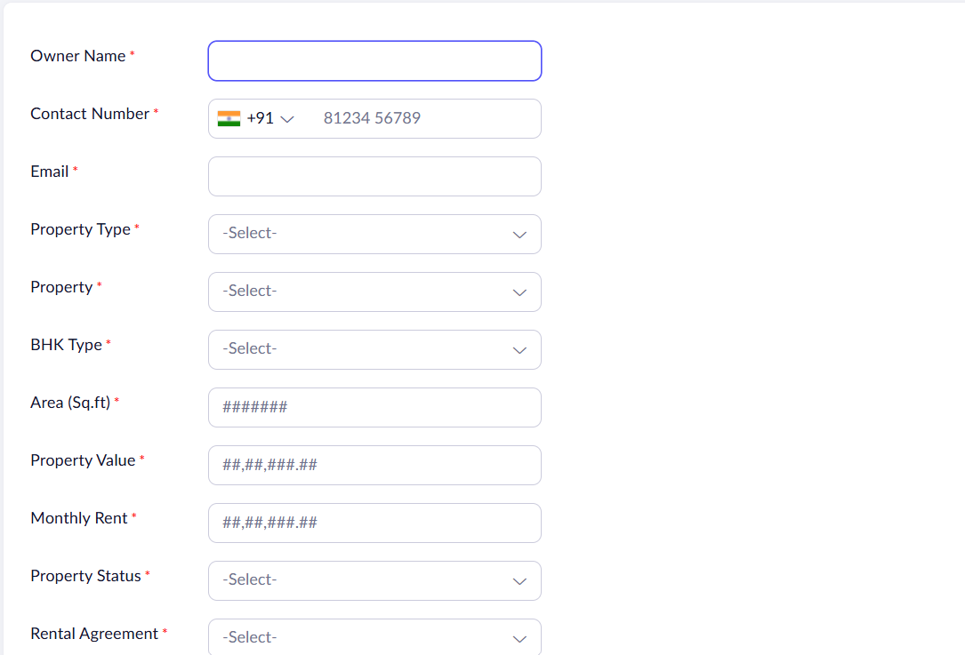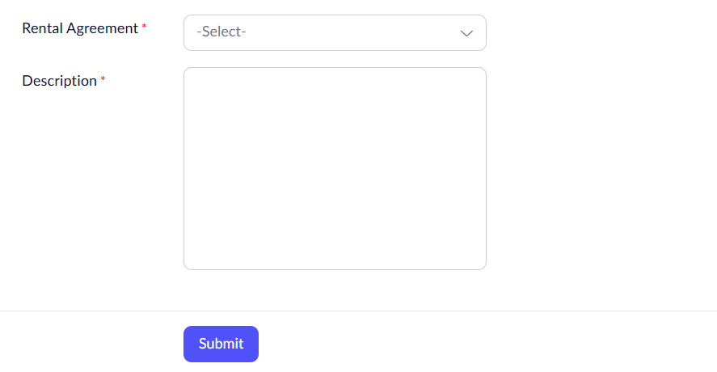
Output
